Name____________________________________________ Period______ Date__________

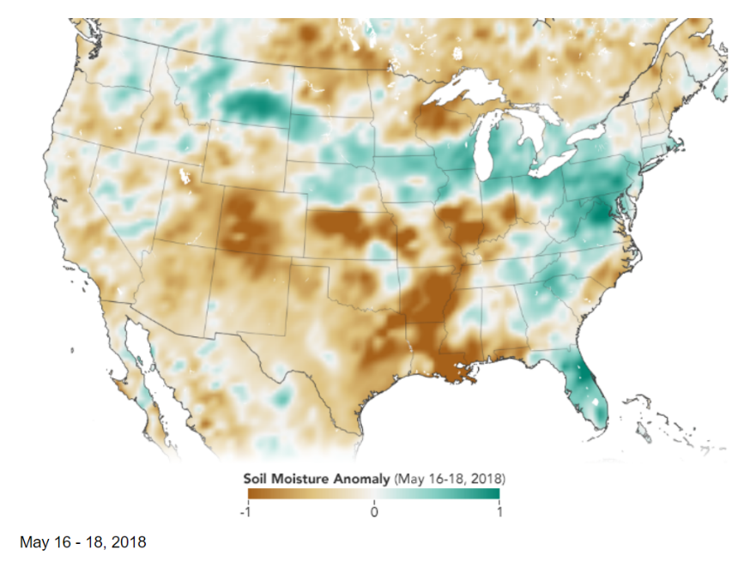United States’ Soil Moisture May 2018

The amount of water contained in the top few centimeters of soil is small on a global scale, but it is critical for agriculture analysts trying to monitor crop productions and other human health influencers. Create as many sentences using the sentence starters by looking at the map.

|  |
| --- |
| I see… |
| I think... |
| I wonder… |